Tanner Allen

Brother Ballard

January 21, 2023

Rhetorical Analysis of Friction Labs

Friction labs is a chalk-based company working to produce the best sports chalk available on the market. Their main tagline is “The new standard in chalk” (Chalk For Athletes Who Demand Better Grip). Their website is well developed with many great aspects, and I believe it to be representative of their mission to revolutionize the use of chalk for athletes everywhere. Two areas that I will begin discussing are image use and color scheme. I believe these to be strong areas of the website that help the audience understand FrictionLabs. However, I also wish to discuss typography and the organization of the website as these elements seem to detract from the website use.

The FrictionLabs website has a strong landing page at first glance having a main section filtering through a slide deck of images. These images mainly depict climbers, with chalk on their hands, gripping to seemingly impossible grades of walls and holding themselves up. The following image depicts this the best, showing a man using the chalk that Friction labs is selling.



Figure : Main landing page for FrictionLabs

Images like this help the viewer understand exactly what they might be able to expect if they were to get their hands on some of that chalk. But this is only one example of good image use. They have an entire section depicting famous climbing athletes that are using FrictionLabs chalk while finding themselves in similar situations as the man depicted above. Needless to say, the images used on this homepage and throughout the website really show just how great the chalk that they create is. But it isn’t the only thing that helps add to the atmosphere that this website needs.

The next thing that really helps add to the message that FrictionLabs is presenting is the color scheme. This website really dives into the use of white space well. It helps depict the message of the chalk that they are selling. Almost their whole website has a white background with small parts being black. These black pieces create a contrast to the website that make important details stand out. Robin Williams describes the use of contrast as a way to draw the viewers eye to certain areas of the page by making them different (Williams, 69). The black and white help this occur as you are drawn to the important places on the page. But they take this even a step further by adding in one final color. FrictionLabs adds in a little mint green for anything to do with their online store. You can see this on the top header of their website.



Figure : Home view of the header

This draws in the viewer’s attention to the fact that they sell this chalk in a subtle enough way that keeps you in. It’s like their chalk itself, subtle on the hands, but keeps you grasping firm to the rock wall. The use of this color scheme brings in the viewer and allows for them to stick around and explore their website a little more.

However, their website is not perfect, and it does have some elements that seem to draw away from FrictionLabs main goal. The first element that is the most obvious is the typography used. From the first picture used you can see how the use of the letters over the image distracts the user’s attention from the picture itself and makes it difficult to focus on one or the other. This then makes it difficult for the user to navigate the rest of the page and site itself, trying to focus back on what they went to the site for. The typography style itself is a good use of a sans serif font and makes the rest of the website pretty easy to read and understand. The colors of the typography when not used on a picture is clear. But when used on the other pictures it becomes difficult to read as they use the same white color scheme with each picture. This doesn’t let it stand out as well for the viewer and is an example of bad placement of the elements on the page.

This layout issue persist beyond just how the typography is used on the images. When it comes to the rest of the homepage when scrolling down it becomes apparent that they were just filling space. As you scroll down the page there is a few images of their best sellers which makes sense for their homepage, but when it comes to the rest of the page it becomes weird. Just below the best sellers is this:

Figure : Image showing the logos of where FrictionLabs has been talked about

To start, these logos are super big compared to the other logos on the page and it seems like a desperate ploy to bring in reasons why their products are good. If FrictionLabs wants to show that they produce a good product they should really have these images before the ones above.

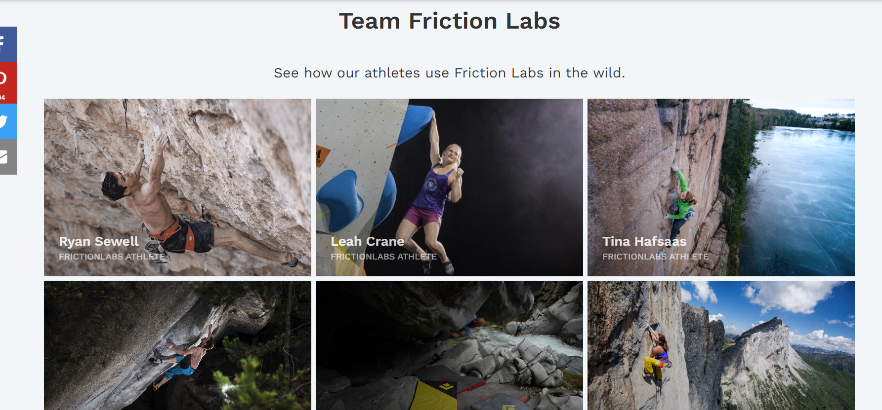

Figure : Images of professional athletes that use FrictionLabs Chalk

We can see that this would provide an emotion inside of someone looking to purchase chalk. Seeing famous climbers using FrictionLab chalk would allow for the viewer to understand the need of the chalk in their own lives. This is what FrictionLabs is trying to do with their website, and they missed the mark with this part.

Overall, we can see that FrictionLabs is selling chalk that really changes how an athlete performs. They are dedicated to providing the best and their website has many areas that accomplish that. However, there are areas that could use improvement to better adhere to a viewer’s usability and ease while on the website. FrictionLabs website is well done and does enough to be what they need, but it doesn’t stand out as an amazing website that people would just visit to see how great it is. The organization of the website could use work, including how they use type on the images provided. But the use of the images along with a great color scheme do help make this website one that accomplishes the task of selling chalk to athletes.

Works Cited

“Chalk for Athletes Who Demand Better Grip.” *FrictionLabs.* January 19, 2023. [frictionlabs.com/](https://frictionlabs.com/)

Williams, Robin. *The Non-Designers Design Book.* 1993. 4th ed., Berkley Calif., PeachPitt, 2015